**RF Framework:**

RF stands for Radio Frequency Mobile Data Entry that allows real time communication between the warehouse employees and the EWM system.

The RF framework supports both browser based and GUI devices to connect to the SAP system. You can create screen templates and merge them to a so called display profile. This display profile is assigned to the presentation device.

In the RF framework there are various functions that can be triggered through with function keys.

A Warehouse Monitor provides an option to monitor the tasks and to take necessary actions accordingly. It is a centralized tool to manage all the activities in a warehouse.

The EWM Warehouse Monitor is a central tool for keeping warehouse managers constantly up-to-date as to the current situation in the warehouse, and to enable them to initiate appropriate responses in light of this situation. The warehouse monitor also contains alert monitoring capabilities, which highlights the warehouse managers towards the actual and potential problematic situations in the warehouse, and provide exception handling tools to assist in the correction of these situations.

Warehouse monitor screen is divided into three parts, which are −

* Node hierarchy tree on left side
* Parent data at right side
* Child data at bottom
* The RF framework supports both GUI and character-based devices, as well as browser-based devices.
* GUI devices are connected to the SAP system just like any other client-dependent PC. The screens can be touch screens, using predefined push buttons, or they can be operated using a keyboard. If you are using touch screens, you simply touch the appropriate positions on the touch screen instead of clicking with the mouse on a push button.
* Character-based devices are linked to the system through SAP Console. SAP Console operates on a 32-bit Windows server and interacts with the RF terminals connected to it. This concept is currently supported by the leading providers of RF terminals.
* The system uses ITS Mobile for connecting browser-based devices.

##### **Bar Code Support:**

The RF framework supports the use of bar codes for identification and verification purposes. SAP currently supports EAN 128 bar code types, but you can also support other types within the RF framework.

##### **Screen Layout Personalization:**

Using the RF screen manager, you can customize the appearance of RF presentation screens, so as to ensure that they are consistent with the attributes of the presentation devices being used.

For more information about the RF screen manager, see Customizing for Extended Warehouse Management under Start of the navigation path Mobile Data Entry Next navigation step Radio Frequency (RF) Framework Next navigation step RF Screen Manager End of the navigation path.

##### **Menu Personalization:**

Using the RF menu manager, you can define your own menus and menu hierarchy for the RF device transactions.

For more information about the RF menu manager, see Customizing for Extended Warehouse Management under Start of the navigation path Mobile Data Entry Next navigation step Radio Frequency (RF) Framework Next navigation step RF Menu Manager End of the navigation path.

##### **Standard RF Features:**

The SAP RF framework provides standard RF features, including the following:

* [Logon](https://help.sap.com/saphelp_ewm900/helpdata/en/df/fe0e41a346ef6fe10000000a1550b0/content.htm" \o "Go to document: Logon)
* [Logoff](https://help.sap.com/saphelp_ewm900/helpdata/en/b3/890f41f83ff06fe10000000a1550b0/content.htm" \o "Go to document: Logoff)
* [Recovery](https://help.sap.com/saphelp_ewm900/helpdata/en/6f/e7fb402eb5f76fe10000000a1550b0/content.htm" \o "Go to document: Recovery)

Work execution transactions for the following warehouse processes:

* [Picking](https://help.sap.com/saphelp_ewm900/helpdata/en/48/d2a6730128581de10000000a42189c/content.htm" \o "Go to document: Picking)
* [Putaway](https://help.sap.com/saphelp_ewm900/helpdata/en/61/ac7941bc1c080de10000000a1550b0/content.htm" \o "Go to document: Putaway)
* [Loading](https://help.sap.com/saphelp_ewm900/helpdata/en/cd/c1904155faa009e10000000a155106/content.htm" \o "Go to document: Loading)
* [Unloading](https://help.sap.com/saphelp_ewm900/helpdata/en/cd/c1904155faa009e10000000a155106/content.htm" \o "Go to document: Unloading)
* [Deconsolidation](https://help.sap.com/saphelp_ewm900/helpdata/en/8a/8c3d415addf923e10000000a155106/content.htm" \o "Go to document: Deconsolidation)
* [Packing](https://help.sap.com/saphelp_ewm900/helpdata/en/cd/8c3d415addf923e10000000a155106/content.htm" \o "Go to document: Packing)
* [Physical Inventory](https://help.sap.com/saphelp_ewm900/helpdata/en/4c/b4e7e34c1f1921e10000000a15822b/content.htm" \o "Go to document: Physical Inventory)
* Replenishment

##### **Warehouse Monitor Components:**

Warehouse monitor screen is divided into three parts, which are −

* Node hierarchy tree on left side
* Parent data at right side
* Child data at bottom

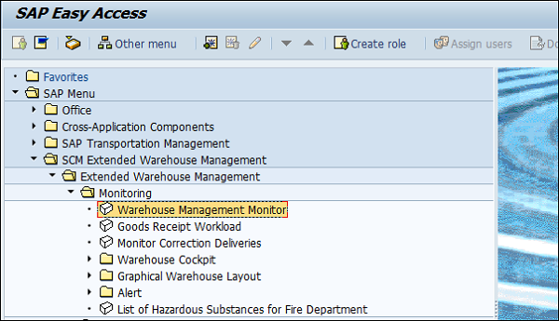

To open the Warehouse monitor, select the Warehouse and monitoring type. You can select SAP Standard Monitor.

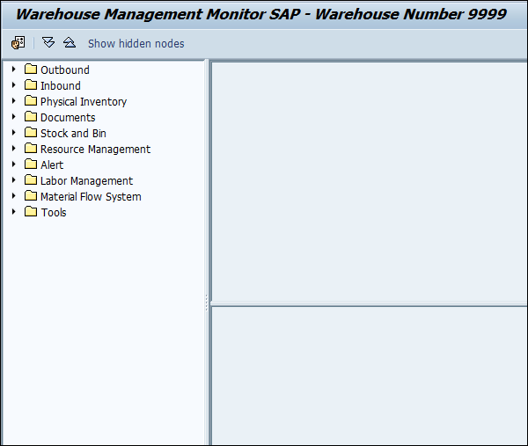

**For example** − There are Alert Nodes in the Warehouse Monitor and then there are Alerts in the SCM Alert Monitor.

